

|  |  |  |
| --- | --- | --- |
| **QUANTITATIVE SCIENCES DEPARTMENT** | |  |
| **Course:** **A2MAA** | |
| **Topic Title**: **Skills Test 3** | |
| Student Name:_____________________________________ | Date: __________2015 | | |
| Special Instructions: No calculator or notes | Time Allowed: 20 minutes | | |
|  | Marks: / 15 | | |

**Question 1 [3 marks]** Complete the addition pyramid below:

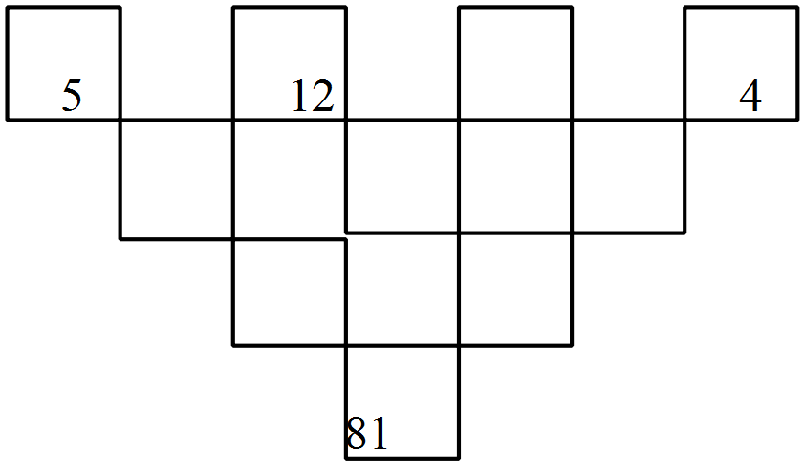

**Question 2 [3 marks]**

I think of a number, add three and multiply that answer by four. If the answer is 44 what number did I first think of?

**Question 3 [3 marks]**

**I** I think of a number, add sixteen and multiply the result by four. The answer is twenty four more than twenty times the number I first thought of. What was that number?

**Question 4 [3 marks]**

I think of a number, subtract it from forty, multiply the result by two and add the number I first thought of and ended up with 30 more than the number I first thought of. Find the number I first thought of.

**Question 5 [3 marks]** Dan is 27 years older than his daughter Liz. In 11 years time, Dan will be twice as old as Liz. How old is Liz now?